Ejercicio de traducción 1 Nombre: Kathryn Atherton
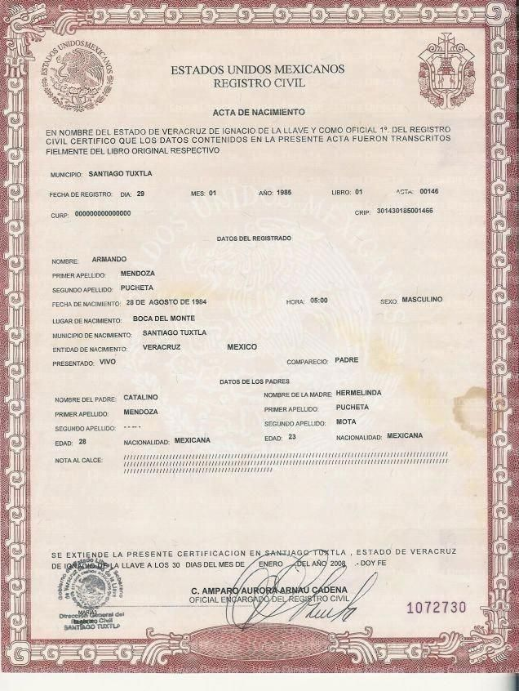
- Tipo de texto: documento
- Extensión aproximada: 1 página
- Tiempo aproximado de traducción: 45 minutos /Tiempo real: 37 minutos

4. Vocabulario básico (marcado en el texto en la primera lectura)
- Registro civil: Civil Registry
- Como Oficial 1°: First Official
- Fielmente: Accurately
- Acta: Certificate
- CURP: Unique Population Registry Code
- CRIP: Mexican Personal Identification Number
- Nota al calce: Footnotes
- Encargado: Manager
- Soberano: Soverign

5. Traducción borrador:

UNITED STATES OF MEXICO
CIVIL REGISTRY
BIRTH CERTIFICATE
IN THE NAME OF THE STATE OF VERACRUZ DE IGNACIO DE LA LLAVE AND AS FIRST OFFICIAL OF THE CIVIL REGISTRY, I HEREBY CERTIFY THAT THE INFORMATION CONTAINED IN THE PRESENT CERTIFICATE WAS TRANSCRIBED ACCURATELY FROM THE CORRESPONDING ORIGINAL BOOK
MUNICIPALITY: SANTIAGO TUXTLA
DATE OF REGISTRY: DAY: 29 MONTH: 01 YEAR: 1985 BOOK: 01 CERTIFICATE: 00146
UNIQUE POPULATION REGISTRY CODE: 00000000000000
MEXICAN PERSONAL IDENTIFICATION NUMBER: 301430185001465
REGISTRY INFORMATION
NAME: ARMANDO
FIRST SURNAME: MENDOZA
SECOND SURNAME: PUCHETA
DATE OF BIRTH: AUGUST 28, 1984 TIME: 05:00 SEX: MALE
BIRTHPLACE: BOCA DEL MONTE
MUNICIPALITY OF BIRTH: SANTIAGO TUXTLA
STATE OF BIRTH: VERACRUZ MEXICO
REGISTERED: ALIVE APPEARED: FATHER
PARENTAL INFORMATION
FATHER’S NAME: CATALINO MOTHER’S NAME: HERMELINDA
FIRST SURNAME: MENDOZA FIRST SURNAME: PUCHETA
SECOND SURNAME: ----- SECOND SURNAME: MOTA
AGE: 28 NATIONALITY: MEXICAN AGE: 23 NATIONALITY: MEXICAN
FOOTNOTES: ///////////////////////////////////////////////////////////////////////////////////////////////
THIS PRESENT CERTIFICATE IS ISSUED IN SANTIAGO TUXTLA, STATE OF VERACRUZ DE IGNACIO DE LA LLAVE ON THE 30TH DAY OF THE MONTH OF JANUARY OF THE YEAR 2008. I ATTEST.
[SIGNATURE]
C. AMPARAO AURORA ARNAU CADENA
OFFICIAL IN CHARGE OF THE CIVIL REGISTRY
GOVERNMENT OF THE FREE AND SOVERIGN STATE OF
VERACRUZ DE IGNACIO DE LA LLAVE
UNITED STATES OF MEXICO

STAMP: GENERAL OFFICE OF THE CIVIL REGISTRY, SANTIAGO TUXTLA

6. Problemas adicionales (si los hay, aquellos que no aparecieron a primera vista sino al escribir la traducción)
- Adding seals and stamps
- United States of Mexico → United Mexican States
- AS first oficial
- Certifies → I hereby certify
- This → The present
- Respective → corresponding
- Hour → time
- Born → registered
- Present → appeared
- This PRESENT certificate
- Extends → is issued
- I give faith → I attest
- Manager → In charge

7. Traducción corregida

SEAL: UNITED STATES OF MEXICO COAT OF ARMS
UNITED MEXICAN STATES
CIVIL REGISTRY
BIRTH CERTIFICATE
IN THE NAME OF THE STATE OF VERACRUZ DE IGNACIO DE LA LLAVE AND AS FIRST OFFICIAL OF THE CIVIL REGISTRY, I HEREBY CERTIFY THAT THE INFORMATION CONTAINED IN THE PRESENT CERTIFICATE WAS TRANSCRIBED ACCURATELY FROM THE CORRESPONDING ORIGINAL BOOK
MUNICIPALITY: SANTIAGO TUXTLA
DATE OF REGISTRY: DAY: 29 MONTH: 01 YEAR: 1985 BOOK: 01 CERTIFICATE: 00146
UNIQUE POPULATION REGISTRY CODE: 00000000000000
MEXICAN PERSONAL IDENTIFICATION NUMBER: 301430185001465
REGISTRY INFORMATION
NAME: ARMANDO
FIRST SURNAME: MENDOZA
SECOND SURNAME: PUCHETA
DATE OF BIRTH: AUGUST 28, 1984 HOUR: 05:00 SEX: MALE
BIRTHPLACE: BOCA DEL MONTE
MUNICIPALITY OF BIRTH: SANTIAGO TUXTLA
STATE OF BIRTH: VERACRUZ MEXICO
REGISTERED: ALIVE APPEARED: FATHER
PARENTAL INFORMATION
FATHER’S NAME: CATALINO MOTHER’S NAME: HERMELINDA
FIRST SURNAME: MENDOZA FIRST SURNAME: PUCHETA
SECOND SURNAME: ----- SECOND SURNAME: MOTA
AGE: 28 NATIONALITY: MEXICAN AGE: 23 NATIONALITY: MEXICAN
FOOTNOTES: ///////////////////////////////////////////////////////////////////////////////////////////////
THIS PRESENT CERTIFICATE IS ISSUED IN SANTIAGO TUXTLA, STATE OF VERACRUZ DE IGNACIO DE LA LLAVE ON THE 30TH DAY OF THE MONTH OF JANUARY OF THE YEAR 2008. I ATTEST.
[SIGNATURE]
C. AMPARAO AURORA ARNAU CADENA
OFFICIAL IN CHARGE OF THE CIVIL REGISTRY
GOVERNMENT OF THE FREE AND SOVERIGN STATE OF
VERACRUZ DE IGNACIO DE LA LLAVE
UNITED STATES OF MEXICO

STAMP: GENERAL OFFICE OF THE CIVIL REGISTRY, SANTIAGO TUXTLA

